SillyCTF – 1c3Gh3tt0 – Writeups

Costco

Frying Chicken?

Minions

geoGRUphical Data

Gru's Lab

It Hertz when IP



Hash Me, If you Can!

1. import hashlib

2.

3. def crack_hash(hash_to_crack):

4. # Minion names list

5. minion_names = [

6. "Bob", "Kevin", "Stuart", "Dave", "Jerry", "Jorge", "Tim", "Mark",

7. "Phil", "Carl", "Lance", "Donny", "Mike", "Tom", "John", "Ken",

8. "Bruce", "Paul", "Chris", "Tony", "Mel", "Steve", "Josh", "Gary", "Larry"

9. ]

10.

11. # Voice actor first names list

12. actor_names = [

13. "Pierre", "Steve", "Jon", "Chris", "Eric", "Jason", "Javier", "Michael",

14. "Benjamin", "Jeff", "Danny", "Russell", "Ken", "Jean-Claude", "Will",

15. "Sandra", "Miranda", "Jennifer", "Kristen", "Geoffrey"

16. ]

17.

18. # Try all combinations

19. for minion in minion_names:

20. for actor in actor_names:

21. password = f"{minion}-{actor}"

22. # Calculate SHA-256 hash

23. hashed = hashlib.sha256(password.encode()).hexdigest()

24. if hashed == hash_to_crack:

25. return password

26. # Print progress (optional)

27. # print(f"Trying: {password}")

28.

29. return None

30.

31. # Given hash

32. target_hash = "2212e01ddbc681e7930e308a27aec679d1ccf36baa26ebec2d43d24813bfa4be"

33.

34. # Attempt to crack the hash

35. result = crack_hash(target_hash)

36.

37. if result:

38. print(f"Password found: sillyCTF{{{result}}}")

39. else:

40. print("Password not found. Try different wordlists.")

41.

Ice Spice

In Her Mood



You Thought I Was Feeling U?

Big Mood Energy

Munch Music



You Smell That?

Farting on the Editors

Gallimaufries

Are You Ready Mr. Krabs

Wittle Gwean Bwean

Waffle House

Where's my waffles?

Culture

It's Turts All the Way Down



Randahm Numbah Generatah

LSD Simulator

Bro Where Is He

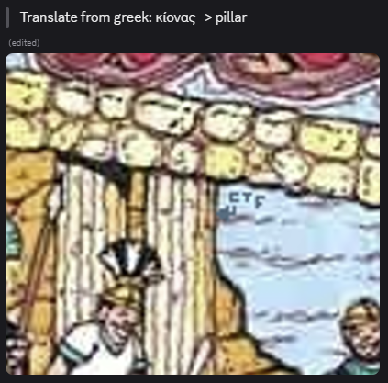

The Serious Zone

Documented

Scratch

ScratchCrypto0

Minecraft

mc_OSINT_1.0

* From the image we could notice blocks in lines for some reason
* Tried some names but were not correct
* Then asked a close friend who plays Minecraft and identified it

mc_OSINT_2.0

mc_OSINT_3.0

* After my close friend identified the previous one, I thought asking him again because he used to play back in those years to try my luck

* I didn’t know if it was correct so tried searching for both diversity 1 and 2 and see what the correct output would be. It was pretty easy to find the information

